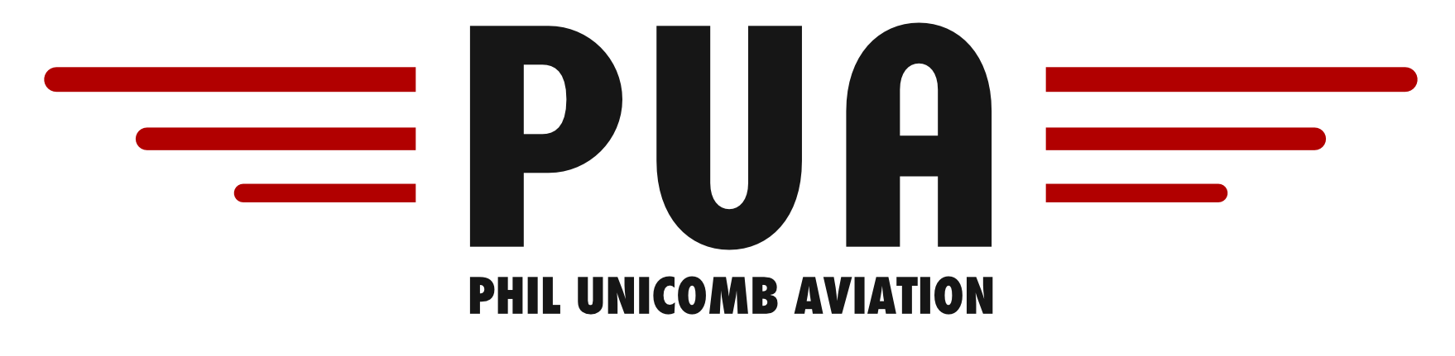
CESSNA 172N VH-DOL AIRCRAFT SPECIFICATIONS
Take off & Landing Speeds
Rotate Speed (Vr) | 60 – 70kts | Normal Approach  (Flaps Up) | 75kts
Take Off Safety Speed | 65kts | Normal Approach  (Flaps 40°) | 70kts
Best Angle (Vx) | 59kts | Short Field Approach (Flaps 40°) | 60kts
Best Rate (Vy) | 73kts | Baulked Approach  (Max Power & Flap 20°) | 55kts
General Speeds
Never Exceed (Vne) | 158kts | Max Window Open | 158kts
Max Normal Operating (Vno) | 127kts | Level Stall Speed (Vs) – flap up | 44kts
Max Maneuvering (Va) | 97kts | Level Stall Speed (Vso) – flap down | 33kts
Max Flap Extension |  | Max Crosswind | 15kts
Flaps 10° | 110kts | TAS | 110kts
Flaps beyond 10° | 85kts | Best Glide Speed | 70kts
Fuel & Oil
Fuel Type | 100LL or 100/130 Avgas | Engine Type and Horsepower | Lycoming O320  160BHP @ 2700RPM
Maximum Fuel | 204 litres | Oil Grade | Aero W100 or W100 Plus
Max Useable Fuel | 189 litres | Maximum Oil | 6 Quarts
Fuel Consumption | 35 Litres/Hour | Minimum Oil | 4 Quarts
**Note: 100LL Avgas is BLUE in colour and 100/130Avgas is GREEN**
Performance
Basic Empty Weight | 711Kg | Maximum Power | 2750 RPM
Max Take off Weight | 1050kg | Static Power | 2280 – 2400 RPM
Max Landing Weight | 1050kg | Normal Cruise | 2450 RPM
 |  | Climb Power | Full Power
** Note: With Full tanks VH-DOL can easily be overloaded! **

