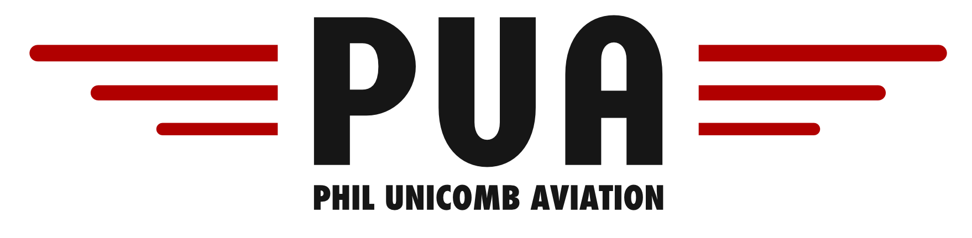
BEECHCRAFT DUCHESS 76 VH-BFP AIRCRAFT SPECIFICATIONS
Airspeeds for Normal Operations
Take off & Landing Speeds
Rotate Speed (Vr) | 71kts | Normal Approach  (Flaps Up) | 87kts
Take Off Safety Speed | 80kts | Normal Approach  (Flaps 30°) | 76kts
Best Angle (Vx) | 71kts | Intentional One-Engine Inoperative Speed (Vsse) | 71kts
Best Rate (Vy) & Blue line (single engine Vy) | 85kts | Max Glide Range | 95kts

General Speeds
Never Exceed (Vne) | 194kts | Max Landing Gear Ext (VLe) | 140kts
Max Normal Operating (Vno) | 154kts | Max Landing Gear Retraction | 112kts
Max Maneuvering (Va) | 132kts | Level Stall Speed (Vs) – gear & flap up | 70kts
Max Flap Extension | 110kts | Level Stall Speed (Vso) – gear & flap down | 60kts
Air Minimum Control (Vmca) | 65kts | Max Crosswind | 25kts
Fuel & Oil
Fuel Type | 100LL Avgas | Engine Type and Horsepower | Lycoming  180BHP @ 2700RPM each
Maximum Fuel | 391 litres | Oil Grade | Aero W100
Max Useable Fuel | 380 litres | Maximum Oil | 8 Quarts
Fuel Consumption | 80 Litres/Hour | Minimum Oil | 4 Quarts
Performance
Basic Empty Weight | 1181Kg | Max Zero Fuel Weight | 1588 kg
Max Take off Weight | 1769 kg | Max RPM | 2700 RPM
Max Landing Weight | 1769 kg | Normal Cruise | 23MP @ 2400 RPM

