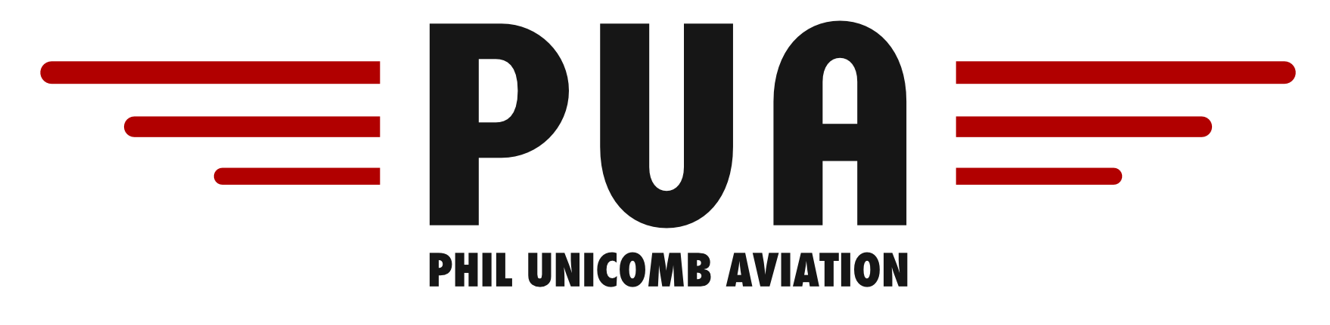
8KCAB DECATHALON VH-ICJ AIRCRAFT SPECIFICATIONS
Airspeeds for Normal Operations
Take off & Landing Speeds
Rotate Speed (Vr) | 60 kts | Normal Approach | 70 kts
Take Off Safety Speed | 58 kts | Shortfield Approach | 65 kts
Best Angle (Vx) | 75 kts | Best Rate (Vy) | 80 kts

General Speeds
Never Exceed (Vne) | 156 kts | TAS | 100 kts
Max Normal Operating (Vno) | 139 kts | Level Stall Speed (Vs) | 42 kts
Turbulence Penetration Speed (Vturb) | 120 kts | Max Crosswind Take off | 17 kts
Best Glide Speed | 70kts | Max Crosswind Landing | 17 kts

Fuel & Oil
Fuel Type | 100LL or 100/130 Avgas | Engine Type and Horsepower | Avco Lycoming 320  160BHP @ 2700rpm
Maximum Fuel | 151 litres | Oil Grade | Aero W100
Max Useable Fuel | 140 litres | Maximum Oil | 8 Quarts
Fuel Consumption | 36 Litres/Hour | Minimum Oil | 6 Quarts
**Note: 100LL Avgas is BLUE in colour and 100/130Avgas is GREEN**
Performance
Basic Empty Weight | 607Kg | Maximum Power | 2700 RPM
Max Take off Weight | 816 kg | Normal Cruise Power | 2400
Max Landing Weight | 816 kg | Max payload with Full Fuel | 100 kg
** Note: With Full tanks VH-ICJ can easily be overloaded! **

